Summary of CATE Activities for 2020
Rice Island:

There was Dredge Material Placement event in August of 2019 which made available approximately 24 acres of high quality CATE habitat for the 2020 breeding season. In contrast, prior to the placement event of 2019 there was approximately 12.5 acres of quality habitat available for the 2019 breeding season.
Given the COVID-induced travel restrictions USACE personnel have not been able to complete establishing the necessary dissuasion materials nor have they been allowed to make daily hazing and monitoring trips. As such, CATE have started using Rice Island and will likely continue to show interest in the island for the 2020 breeding season (Fig. 1&2).
On 3-21-20 – 3-25-20 USACE personnel deployed dissuasion materials in areas that promised to be most preferred by CATE on Rice Island. COVID – shut down travel the following week.
Two monitoring trip have been made since.
On 4/23/20 there were 103 CATE in Bowl and 56 CATE loafing on the beach of Rice Island.
On 4/28/20 there were:
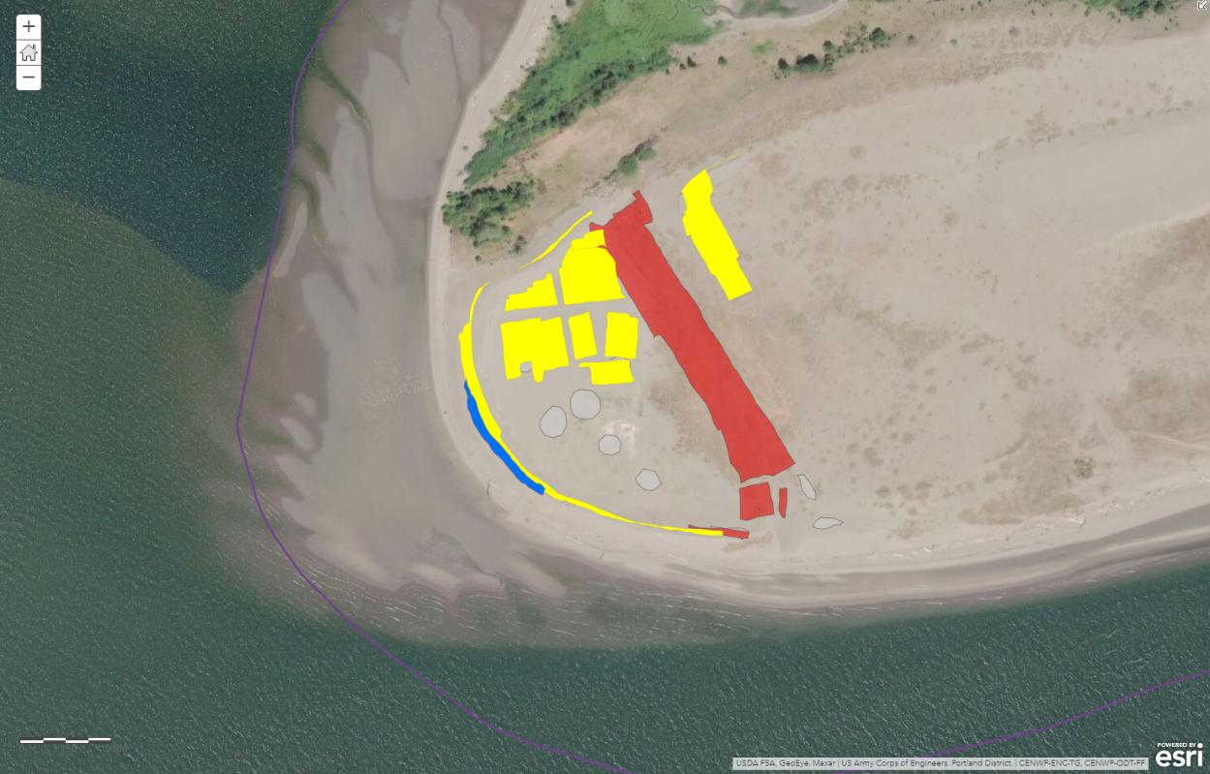
Figure 1. Rice Island: Yellow and blue = 2019 dissuasion. A total of 4.58 acres. Red = 2020 dissuasion. A total of 4.72 acres.
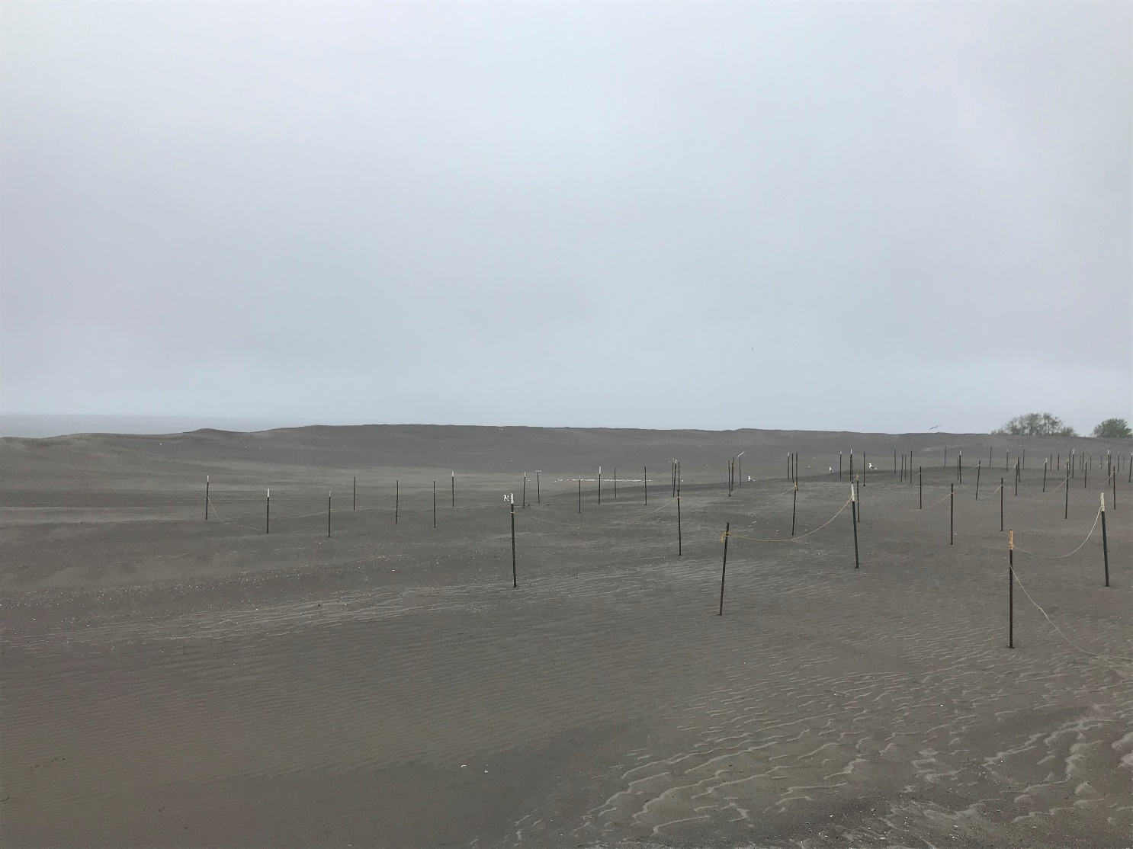
Figure 2. Rice Island 4/23/20. Ropes and flagging being installed and CATe sitting in the background. CATE were flushed repeatedly and returned.
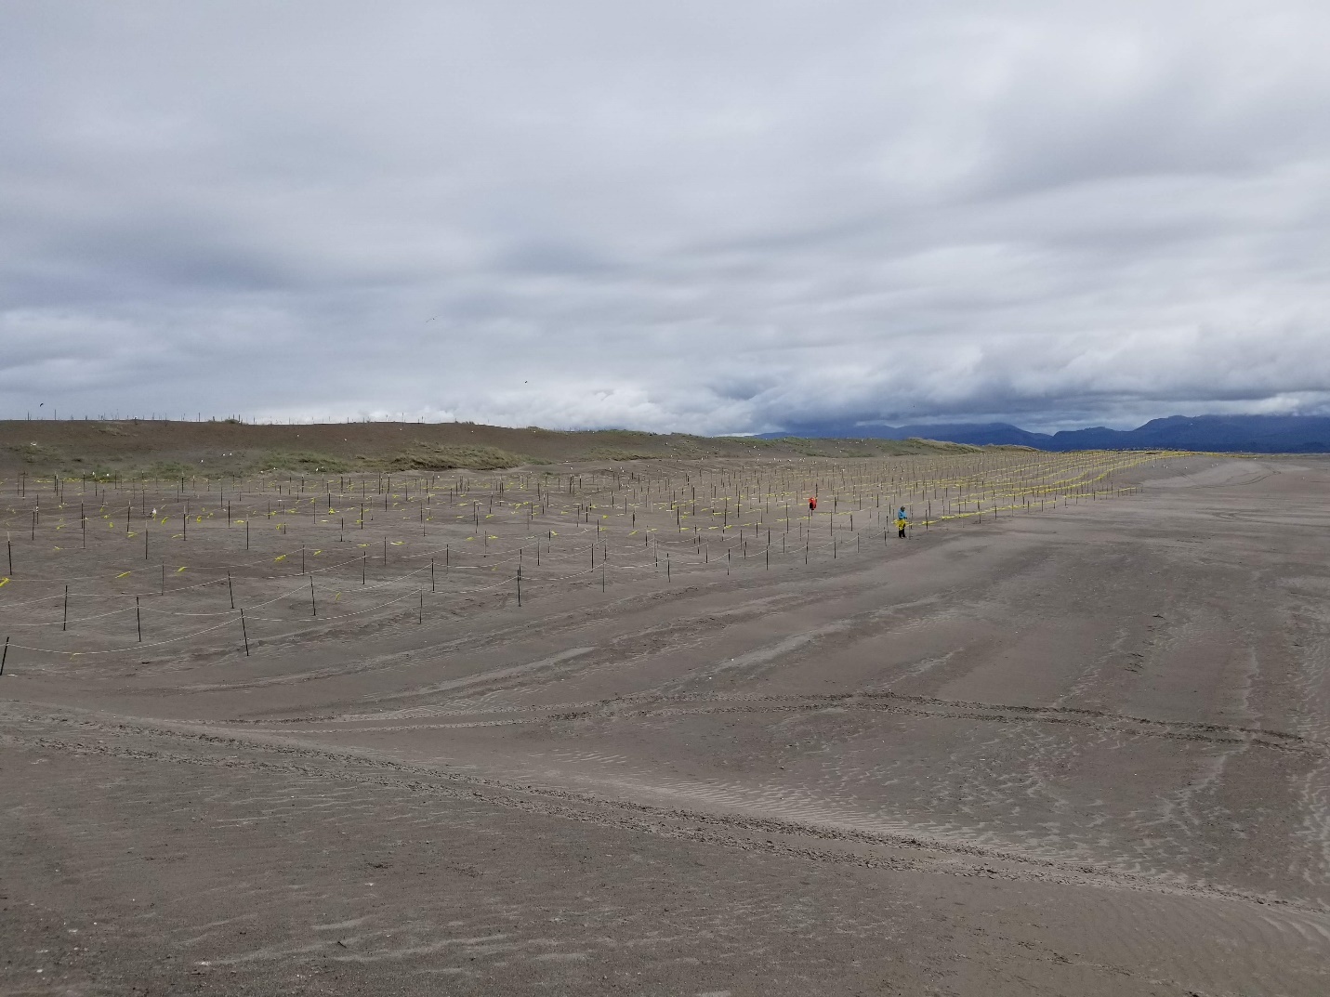
Figure 3. Rice Island 3/22/20. Rope and flagging array being established.

East Sand Island:
The colony established in 2019 survived the winter season and was re-set and prepared on April 2, 2020. Dissuasion was established immediately around the colony on 4/16/20 (Figure 4 – 6). The first CATE were documented on 4/2/20, and CATe were present on the colony as of 4/16/20.

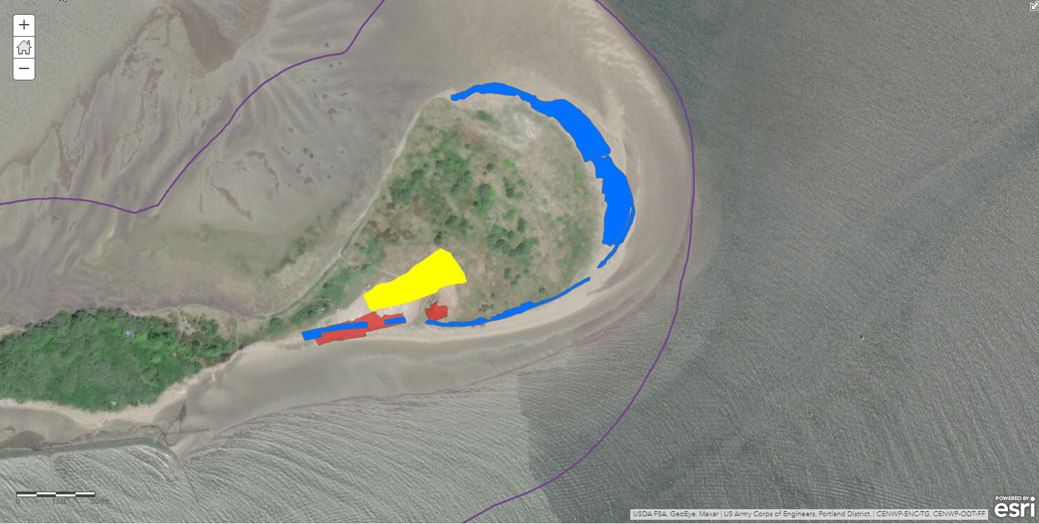
Figure 4. East Sand Island: Yellow = 2019 & 2020 Colony. Blue = 2019 dissuasion. A total of 2.11 acres. Red = 2020 dissuasion. A total of 0.75 acres.
On ESI as of 4/16/20 there were 250 CATE on Beach and 200 CATE in the Colony.

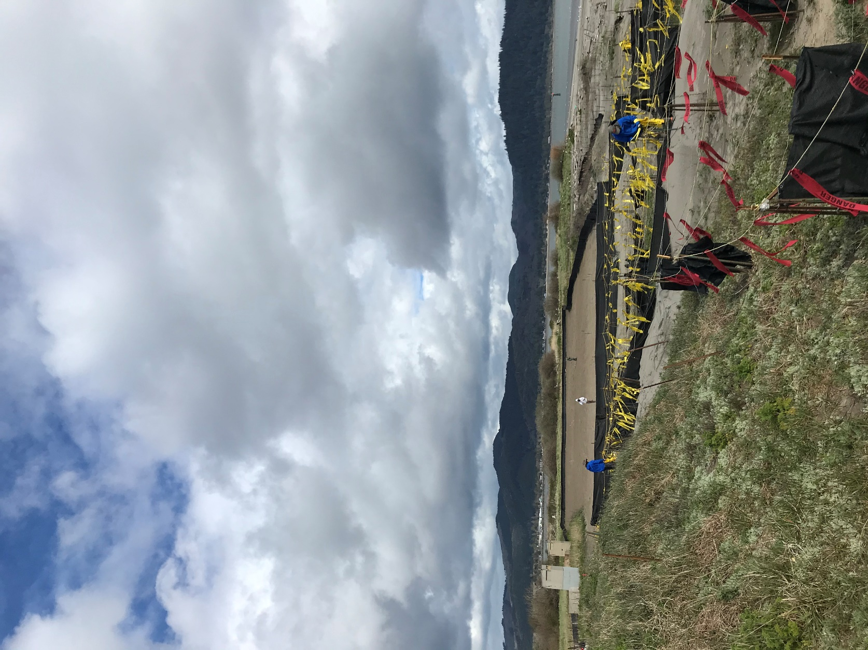
Figure 5. East sand Island colony looking east.
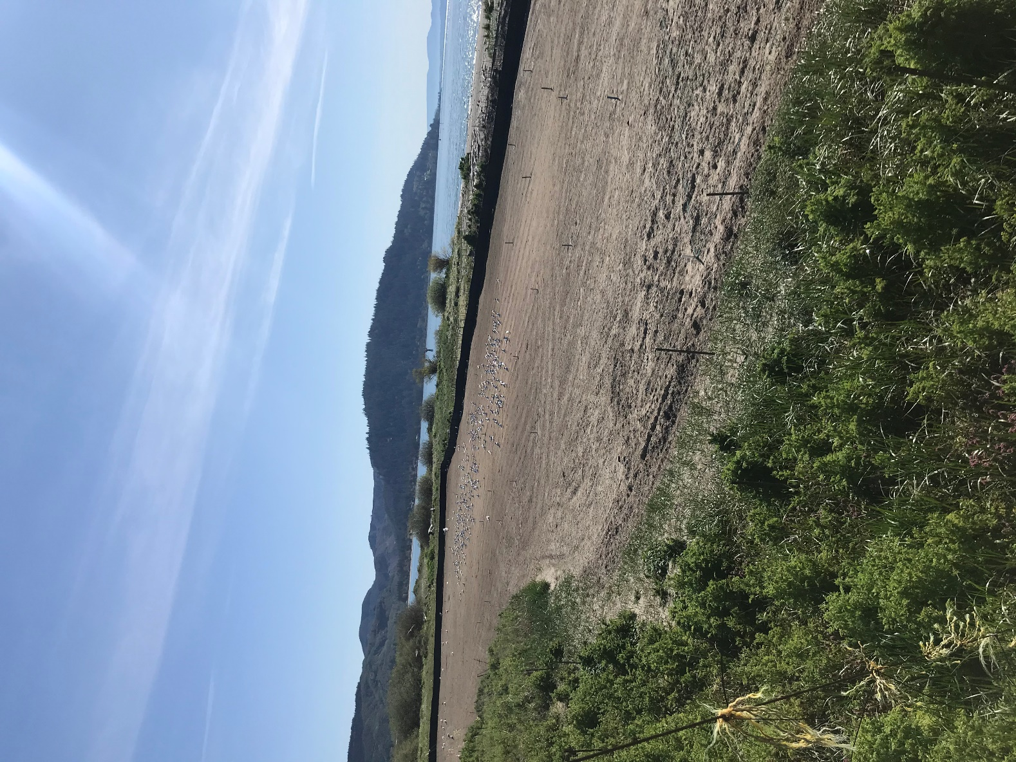
Figure 6. East Sand island looking South East. Note CATE and Plots for colony counts in view.

